**International Literacy Day**

On 8th September 2025, the Department of Political Science, Himachal Pradesh University (HPU), organized a special event to observe International Literacy Day, hosted by Dr. Vikas Singh and Dr. Mini Pathak Dogra. The event focused on the theme “Transcending Traditional Literacy to Digital Literacy,” highlighting the urgent need to adapt literacy education for the digital age. Dr. Vikas Singh, in his inaugural address, emphasized the critical role of literacy in empowering individuals and strengthening democratic societies, while Dr. Mini Pathak Dogra’s keynote speech underlined the importance of integrating digital tools into the learning process. A panel discussion featuring experts from education, technology, and public policy provided insights into the challenges and opportunities of enhancing digital literacy.

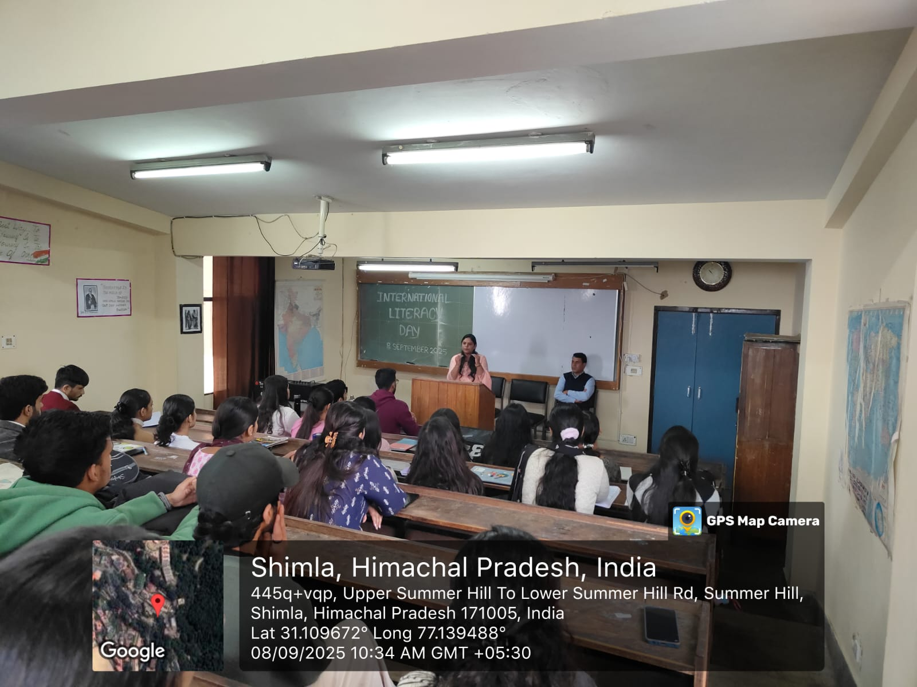

The event also included interactive sessions where students actively engaged with digital literacy tools and platforms, promoting hands-on learning. The gathering attracted enthusiastic participation from students, faculty members, and guests across various disciplines of HPU, fostering meaningful dialogue on how literacy must evolve to remain relevant. 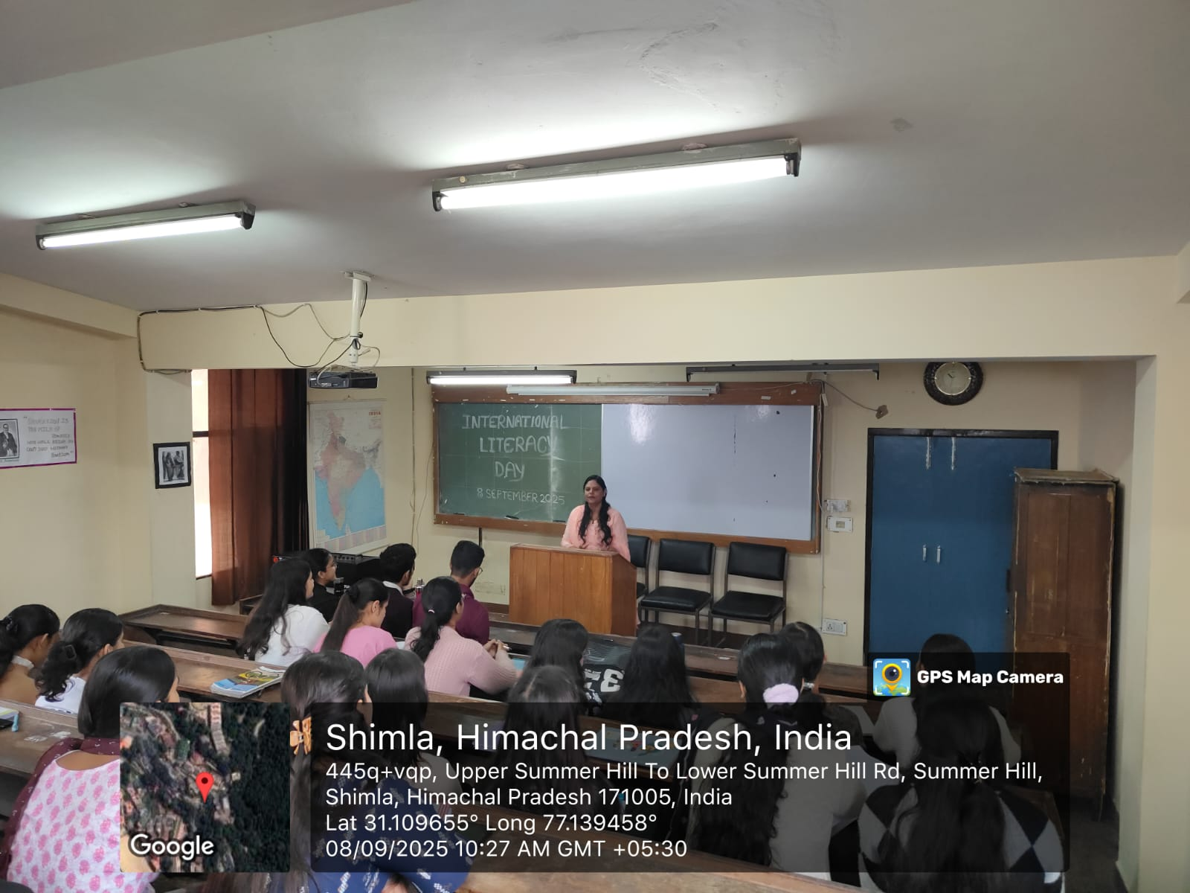

The event succeeded in raising awareness about the shift from traditional to digital literacy and inspired participants to think critically about the role of digital education in today’s world. It concluded with a collective commitment to advancing inclusive and digital literacy for all.

