**THE EDGE AGES (TEA)**

**A MONTHLY NEWSLETTER**

**OF**

**DEPARTMENT OF COMMERCE, HIMACHAL PRADESH UNIVERSITY, SHIMLA**

**ISSUE-20 01.07.2025 to 31.07.2025**

**Aims and Objectives:**

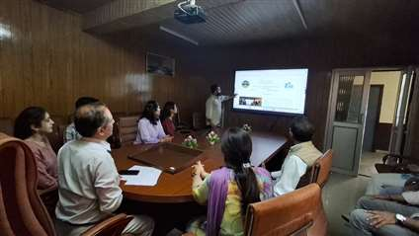The Edge Ages (TEA) is a monthly Online Newsletter of the Department of Commerce, Himachal Pradesh University, Shimla. Initially, fortnightly Online Newsletter, THE EDGE AGES (TEA) was started by the department w.e.f. 1.8.2024. The E-Newsletter has successfully completed one year of online publication. It is to focus on academic and other perspectives useful for students and readers especially for commerce and business. The Newsletter updates the activities of the Department of Commerce, Himachal Pradesh University is meant for enriching knowledge and encouraging young and enthusiastic students and researchers to contribute their original write-ups as well as to convey update information which is useful for synergizing knowledge in the field of commerce and is the effort in the benefit of all stakeholders and for welfare of the future generations. The information and write-ups can be considered for publication if are ensuring originality and recommendations of the reviewers including editorial board.

**Editorial Board:**

**Chief Editor:**

* Dr. Devinder Sharma, Professor & Chairman, Department of Commerce, H.P. University, Shimla.

**Managing Editor:**

* Dr. Raj Kumar Singh, Professor, Department of Commerce, H.P. University, Shimla.

**Advisory Committee**:

* + - Professor Vijay Kumar Sharma
    - Professor Kulbhushan Chandel

**Editorial Board**

1. Dr. Manoj Sharma, Assistant Professor, Department of Commerce, H.P. University, Shimla.
2. Dr. Vijeta Sharma, Assistant Professor, Department of Commerce, H.P. University, Shimla.
3. Priya Negi (Research Scholar)
4. Sheifali (Research Scholar)
5. Ashish (Research Scholar)
6. Aditi Sharma (Research Scholar)
7. Palak Sidhu (Research Scholar)
8. Alisha (Research Scholar)

**Web Management Board**

* Web Manager: Shashi Dogra, Web In-Charge, Computer Center, Himachal Pradesh University, Shimla.
* Web Management Board (Scholars)

1. Ashish (Research Scholar)
2. Vishal Kaushal (Research Scholar)
3. Sunil Kumar (Research Scholar)
4. Satish Kumar (Research Scholar)
5. Tarun Sharma (Research Scholar)

**Photography In-Charge (Scholars and Students)**

1. Paramjeet (Research Scholar)
2. Tarini Kanwar (Research Scholar)

**मुख्य संपादक का संदेश**

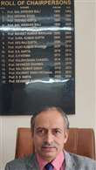हिमाचल प्रदेश विश्वविद्यालय के वाणिज्य विभाग की मासिक न्यूज़लेटर द एज एजेज़ (TEA) को एक वर्ष पूर्ण हुआ है । **न्यूज़लेटर के 20वें अंक** का सफलतापूर्वक प्रकाशन कर दिया गया है, जो हमारे **संपादकीय एवं वेब प्रबंधन टीम** की निष्ठा, तथा **फोटोग्राफी टीम** के सहयोग का परिणाम है।

यह अंक भी पूर्व अंकों की तरह **शैक्षणिक गतिविधियों, अनुसंधान संबंधी समाचारों, विभागीय उपलब्धियों**, और वाणिज्य विषय के विद्यार्थियों व युवा पेशेवरों के लिए **रोज़गार व अनुभव के अवसरों** की समृद्ध जानकारी प्रस्तुत करता है। साथ ही यह **शैक्षणिक संवाद और सीखने** का एक प्रभावशाली मंच भी प्रदान करता है।

इस विशेष अवसर पर मैं उन सभी व्यक्तियों को **हार्दिक बधाई और धन्यवाद** देना चाहता हूँ, जिनके सक्रिय योगदान और समर्पण से इस अंक का प्रकाशन संभव हो पाया। आपका यह योगदान हमारे पाठकों को निरंतर ज्ञानवर्धक सामग्री प्रदान कर रहा है।

मुझे विश्वास है कि TEA के मासिक अंकों का यह **संग्रह**, वाणिज्य विभाग के प्रयासों को भविष्य की पीढ़ियों के समक्ष उजागर करेगा और उन्हें प्रेरणा प्रदान करेगा।

शुभकामनाओं सहित,

**प्रोफेसर देविंदर शर्मा**  
मुख्य संपादक, द एज एजेज़  
विभागाध्यक्ष, वाणिज्य विभाग  
हिमाचल प्रदेश विश्वविद्यालय

**प्रबंध संपादक की कलम से**

प्रिय छात्रगण, संकाय सदस्यगण एवं पाठकगण,

सदैव की भांति मै पुनः नए क्रमांक क़े सफलतापूर्वक प्रकाशन की शुभकामनाऍ देता हूँ । हमे नहीं भूलना है की युवा मनों और उनके चरित्र के निर्माण में मूल्यों की बुद्धिमत्ता (Value Wisdom) का अत्यंत महत्व है। हिमाचल प्रदेश विश्वविद्यालय के वाणिज्य विभाग द्वारा यह सतत प्रयास किया जा रहा है कि छात्रों में जीवन मूल्यों को आत्मसात कराया जाए, जिससे वे समाज में सकारात्मक परिवर्तन ला सकें।

मुझे यह बताते हुए अत्यंत प्रसन्नता हो रही है कि हमारा विभाग निरंतर शिक्षा के क्षेत्र में उत्कृष्टता प्राप्त करने हेतु प्रयासरत है और इसके नवीनतम उपलब्धियों एवं प्रगति को आपके साथ साझा कर रहा हूँ।

मैं आप सभी से आग्रह करता हूँ कि आप अपने दैनिक जीवन में प्रेम, सम्मान, अहिंसा, सत्यनिष्ठा, धैर्य और क्षमा जैसे मूल्यों को अपनाएँ और संस्थान तथा समाज में एक सुंदर, आनंदमय एवं शांतिपूर्ण वातावरण का निर्माण करें। में पत्रिका के एक वर्ष पूर्ण होने की बधाई देता हूँ और अपेक्षा करता हूँ की छात्र इस पत्रिका को पढ़ कर ज्ञान अर्जित करेंगे व् वाणिज्य विभाग की गतिविधियों से अवगत होंगे ।

सादर,  
**प्रोफेसर राज कुमार सिंह**  
**प्रबंध संपादक**

**विद्यार्थी एवं शोधार्थी संपादकीय बोर्ड का संदेश**

इस मासिक समाचार पत्रिका के इस अंक में हम अपने सभी पाठकों और लेख प्रेषकों के प्रति हार्दिक आभार व्यक्त करना चाहते हैं। आप सभी की सहभागिता, प्रोत्साहन, रचनात्मक सुझाव और निरंतर प्रेरणा ही हमारी ऊर्जा को समन्वित करती है और हमें वाणिज्य विभाग की प्रत्येक गतिविधि से आपको अवगत कराने हेतु सक्रिय बनाए रखती है।

हमारी टीम सदैव तत्पर रहती है और पूरी मेहनत के साथ कार्य कर रही है ताकि आप तक विभाग की गतिविधियों की जानकारी समय पर पहुँचे। हमें आशा है कि आपको इस अंक की प्रस्तुति पसंद आएगी। साथ ही हम आपके बहुमूल्य सुझावों और उत्साहवर्धन की प्रतीक्षा करते हैं।

**शोधार्थी एवं विद्यार्थी संपादकीय, फोटोग्राफी एवं वेब टीम**

**OUR MOTTO**

Spread knowledge, excel and prove dynamic potential in the sphere of different sectors as experts dealing commerce by refreshing The Edge Ages of commerce updates.

**HIMACHAL PRADESH UNIVERSITY**

**(NAAC Accredited ‘A’ Grade University)**

**Department of Commerce, Shimla-5**

**ACADEMIC CALENDAR FOR THE SEMESTER W.E.F. July 1, 2025 TO December-31, 2025**

|  |  |  |  |  |
| --- | --- | --- | --- | --- |
| **Month** | **Dates From- To** | **Teaching Days** | **Celebrations** | **Additional Celebrations subject to funds provided by the University** |
| **July** | 1.7.25 to 20.7.25 | Admission Process | - | * Skill Learning on Stocks/ GST/Tax etc. * Conversation with Women Entrepreneurs * Workshop on Research Methodology * Trade Fair * Plantation & Clean Environment |
| 21.7.25 to 31.7.25 | 10 | 21.7.25- Induction Programme |
| **August** | 1.8.25 to 31.8.25 | 23 | 7.8.25- National Handloom Day  26.8.25- Women Equity Day with International Day for Elimination of Violence Against Women of dated 25.11.25  31.8.25- National Unity Day |
| **September** | 1.9.25 to 30.9.25 | 25 | 5.9.25- Teachers Day with World Teachers Day of 5.10.25  14.9.25- Hindi Diwas  18.9.25- World Bamboo Day with World Environment Health Day of 26.9.25 |
| **October** | 1.10.25 to 31.10.25 | 22 | 2.10.25- International Day for Non-Violence  15.10.25- World Students Day with World Statistics Day of 20.10.25 |
| **November** | 01.11.25 to 16.11.25 | 11 | - | Students Assignments and Presentations etc. |
| **November-December** | 17.11.25 to 31.12.25 | NIL | Preparatory Days and End Semester Exams | Participation of all and Special Lecture |
| **Total Days** | | 91 |  |  |
| **Additional Academic Calendar (for Ph.D. Course Work Students and Academic Participation)** | | | | |
| They will have to attend the Viva-Voce Examination presentations of Ph.D. Scholars, give presentations on rotation basis, participate and involve in the departmental events and attend academic and research programmes. | | | | |
| Attendance of M.Com. students and Ph.D. Scholars with the approval of Chairman, in the Seminar/Workshop/Special Lecture in the Semester will be considered for Academic Attendance Count as per Norms. | | | | |
| Induction Programme will be on the first week of the start of the Semester. It will be compulsory for the students of M.Com.-1 to attend the Induction Programme. The theme of the Induction Programme will be:  **WE, THE TEAM TOWARDS EXCELLENCE OF LEARNING AND OVERALL GROWTH** | | | | |

**CHAIRMAN**

**New Session started from 28.07.2025 with the Induction Programme. The theme of the Induction Programme was:**

**WE, THE TEAM TOWARDS EXCELLENCE OF LEARNING AND OVERALL GROWTH**

**Teaching Faculty members and Research Scholars interacted with the Incumbent students and made them aware about the academic, research and overall environment of the University. Students were convinced to share their problems and were ensured cooperation and support from the entire team of the Department. On 29.7.2025, students attended the Declamation Competition followed by Special Programme on Operation Sindhoor in the Auditorium of Himachal Pradesh University.**

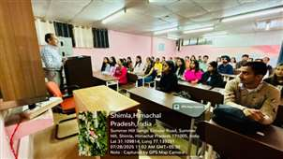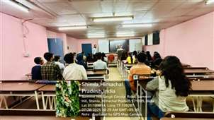

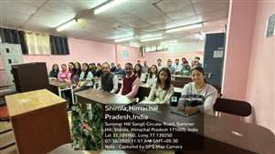 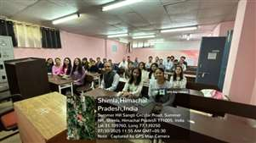

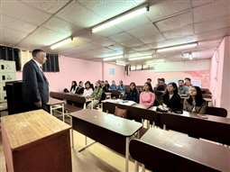 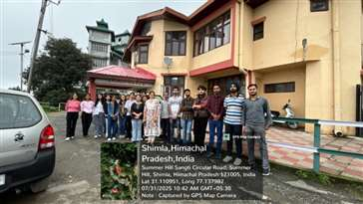

**Photos during Induction Programme**

**s**

**PHILANTHROPIC MOVE**

Devastating Cloud Bursting happenings have lost properties, livestock and people in different places of Himachal Pradesh especially Saraj region of Mandi District. There is no human action and support which can fill the loss. Teaching faculty members have sympathy and have contributed own ways to the different groups to assist the families of the region.

From own resources, cautions were fixed this month of July on the benches of Room Number 105 (Class Room of M.Com. 2nd Year). Now for the last long, the sitting arrangement of the room could be improved by own self without assistance taken from the University.

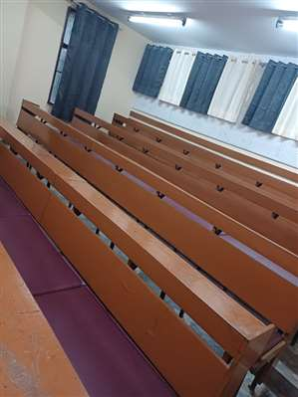 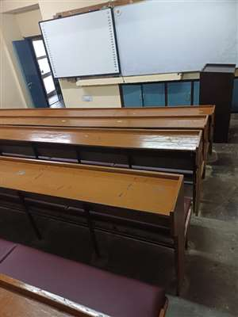

Photos of Room Number 105

**INTERACTIVE SYSTEM**

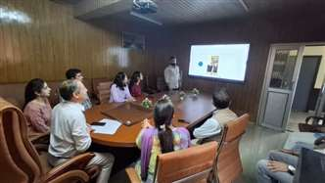 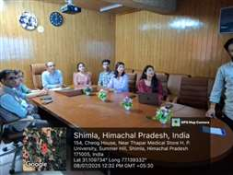

**E-NEWSLETTER THE EDGE AGES (TEA) Being Watched by Department of Commerce Teachers, Research Scholars, Students and Teachers from other departments of the University on 8.7.2025**

**Counseling for admission in M.Com. for the Session 2025-26 was held on 7.7.2025 and 8.7.2025** 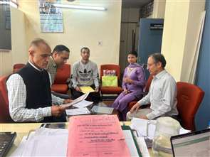 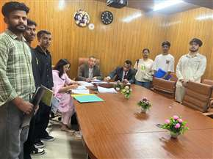

Photo of Committee-I & II in the office of Chairman and Conference Room of Department of Commerce.

**Counseling and Interview for admission in Ph.D. for the Session 2024-25 was held on 26.7.2025. The counseling and Interview took place in the Conference Room of the Department.**

**ACADEMIC AND RESEARCH EXPOSURE**

Project Evaluation and Viva-Voce and Comprehensive Viva-Voce examinations of students of M.Com. students of the Department of Commerce were held on 19.7.2025 from 9.30 A.M. in the office of Chairman, Department of Commerce. Professor Luxmi Malodia, UBS, Panjab University, Chandigarh was External Examiner to take the said examinations.

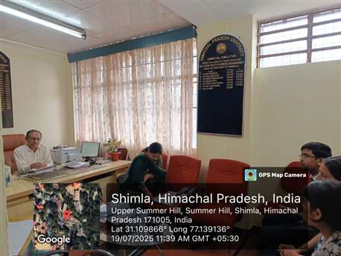

Photo of the Project Evaluation and Viva-Voce Examination of M.Com on 19.7.2025

**MEETINGS:**

Workshop for framing curricula under Internship Embedded Program for B.Com. through CRISP was held w.e.f. 23.07.2025 to 25.07.2025 in the Department of Commerce. The workshop was followed by the meeting of the Board of Studies (UG) Commerce in which the invitee members of the workshop were also present as special invitees on 25.07.2025.

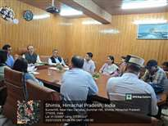 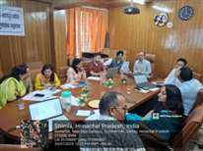 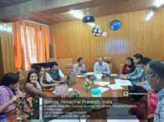

Photos of the Meeting of Board of Studies-Cum Workshop for Framing Curriculum

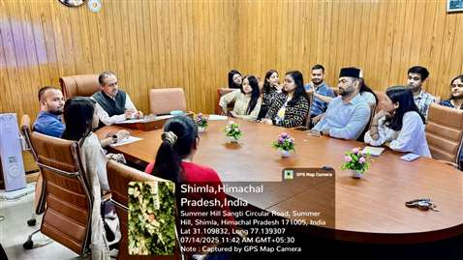

Photo of the Meeting with Different Scholarship Holders of Ph.D. Commerce.

Meeting of different scholarship holders of Ph.D. and other students of Department of Commerce was held under the Chairmanship of Professor Devinder Sharma on 14.07.2025 at 11.30 A.M. in the Conference Room to discuss the role and responsibilities and to plan the academic, research and developmental initiatives for the Session 2025-26.

Meeting of the Department Council of Commerce was held on 15.07.2025 at 11.30 A.M. in the room of Chairman to discuss the issues and initiatives to be taken in the Current Ongoing Session 2025-26 for qualitative delivery of academic, research and other activities. The academic Time Schedule for the current Academic Session has also been finalized in the meeting.

Photo of the Meeting of Board of Studies with Executive of CRISP (AEDPs) and followed by it, Meeting of the Board of Studies (UG) Commerce dated 13.06.2025.

**CELEBRATIONS/EVENTS**

Himachal Pradesh University Day was celebrated on 22.07.2025.

**ACADEMIC-RESEARCH ASSIGNMENTS**

Teaching Faculty members represented as Resource Persons in the Conferences and workshops. Viva-Voce examinations of M.Com. were taken by the teachers of the Department in the affiliated private and Govt. Colleges of Himachal Pradesh University where M.Com. is running. They attended duties of the other universities including Viva-Voce examination, Board Meetings, Resource Persons etc. and have performed inspection duties.

**PHOTO GALLERY**

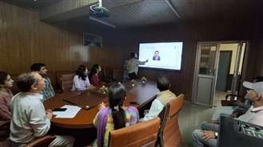 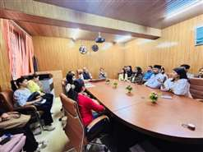

E-Newsletter TEA Being Watched by Faculty of Sanskrit Meeting with Research Scholars

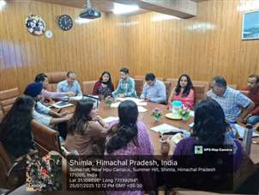 

Meeting: Special Invitees & BOS(UG) Members Resource Person Dr. Joginder Saklani in the

Induction Programme

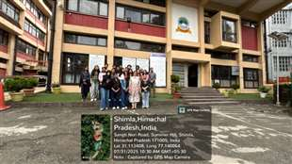 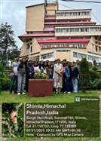

During Induction Programme: Visit to Vice-Chancellor Office Building and Library Building

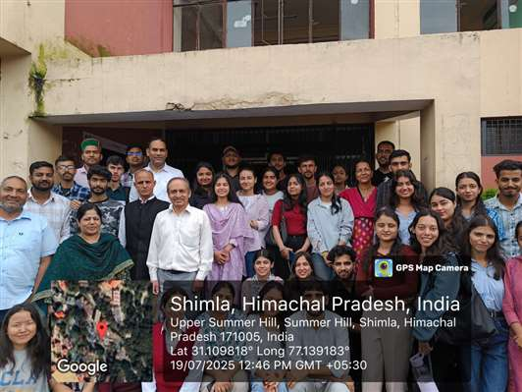

Sweet Memories of M.Com Outgoing Class 2025; Photo after Project Evaluation Exam outside the Gate of Department of Commerce.

**EDITORIAL LEARNING**

INDUCTION PROGRAMME IN THE EDUCATIONAL INSTITUTIONS FOR ALIGNING INCUMBENTS- WHY AND HOW?

Every new person needs aligned with the new environment. It is mandatory for psychological acceptance of the environment, its understanding, understanding of the fellow beings, adjusting with the environment, practical understandings and developing the sense of belongingness. It is essential for development of personalities thereby, having the congenial environment where every- one has the feeling to get adjusted and to support others. University Grants Commission has initiated for Induction programmes for the incumbents which is quite meaningful. At this juncture, it is pertinent to understand as to why and how Induction Programmes should be proceeded? So far the question why Induction Programmes should be there in the educational institutions, it is quite clear that when a person has to enter into the new environment, he or she has bundles of questions in the form of hurdles adapting the new environment. Such hurdles sometimes emerge in the form of fear and troublesome for such persons only due to apprehensive conditions. If such conditions are not addressed, the concerned person can-not adjust with the new environment and it will not be beneficial for that person. Further, as stated earlier, there are a series of reasons justifying need for Induction Programmes. Now, the point is how to conduct the Induction Programmes so that the role of the educational institution be considered instrumental to address the issues of the incumbents. In this instance, especially if we talk about the educational institutions, for the students the need is to interact in a way that the incumbent feels being adjusted in the new environment, feels comfort, psychologically supporting the incumbent, encouraging, motivating and persons being able to practically understand the new environment. As such, there is a need to make them convinced that we are to assist and support. We all are for the common cause and we, as a team will support each other. Himachal Pradesh University Department of Commerce organized Induction Programmes for students of Master of Commerce w.e.f. 28.7.2025. The theme of the programmes was WE, THE TEAM TORARDS EXCELLENCE OF LEARNING AND OVERALL GROWTH. All aspects were kept into priority while organizing the Induction Programmes.

Prof. Devinder Sharma

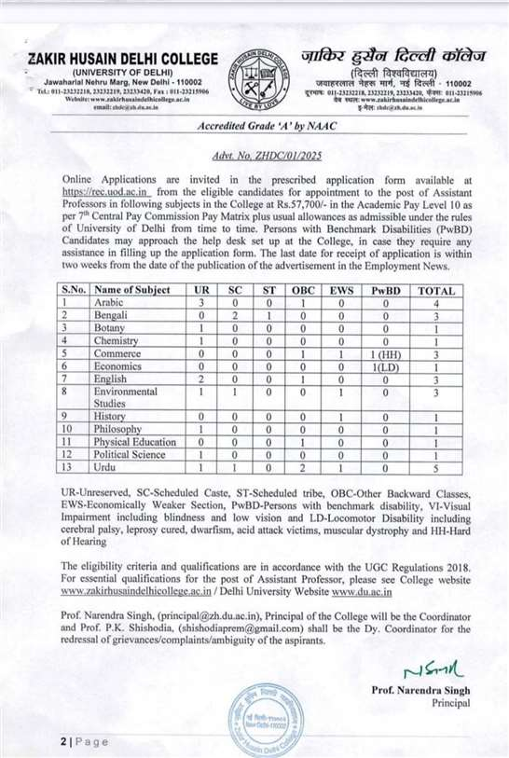

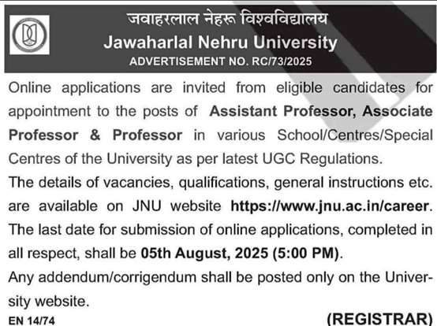

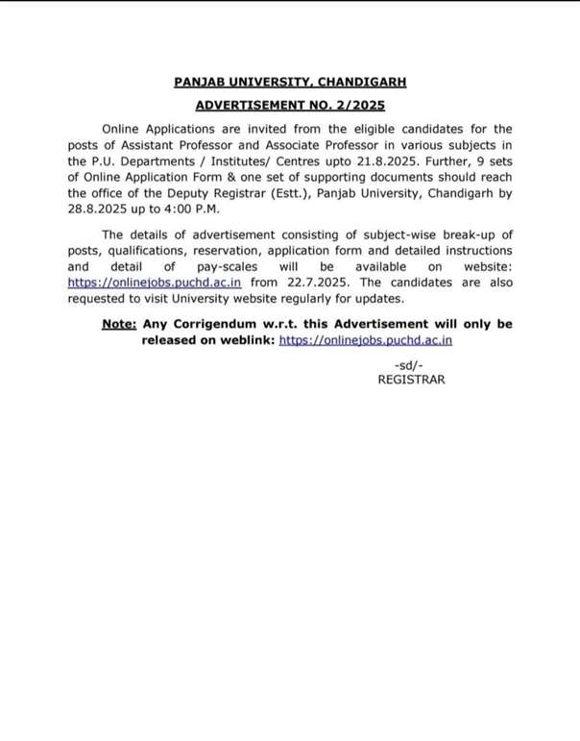

**It’s the beginning to update……..**